Woodland Road Public School

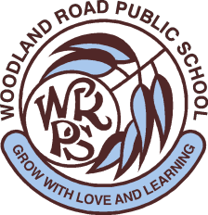

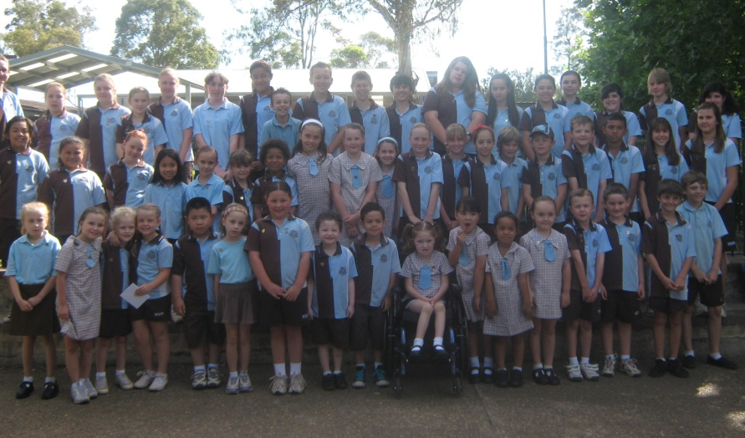

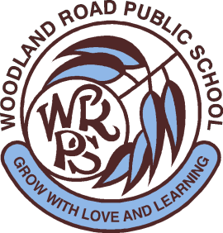

Student Welfare Policy
Revised: 2012

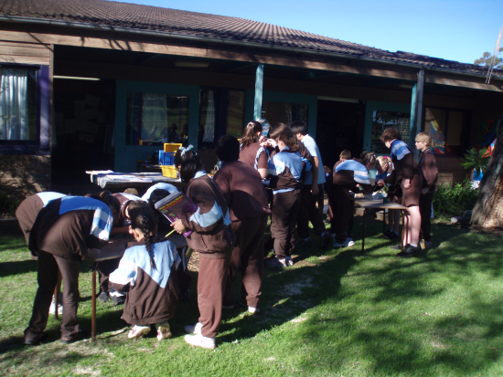

Student Welfare Policy
2010
Student Welfare Policy
2010
Student Welfare Policy
2010

Student Welfare Policy
2010
Student Welfare Policy
2010

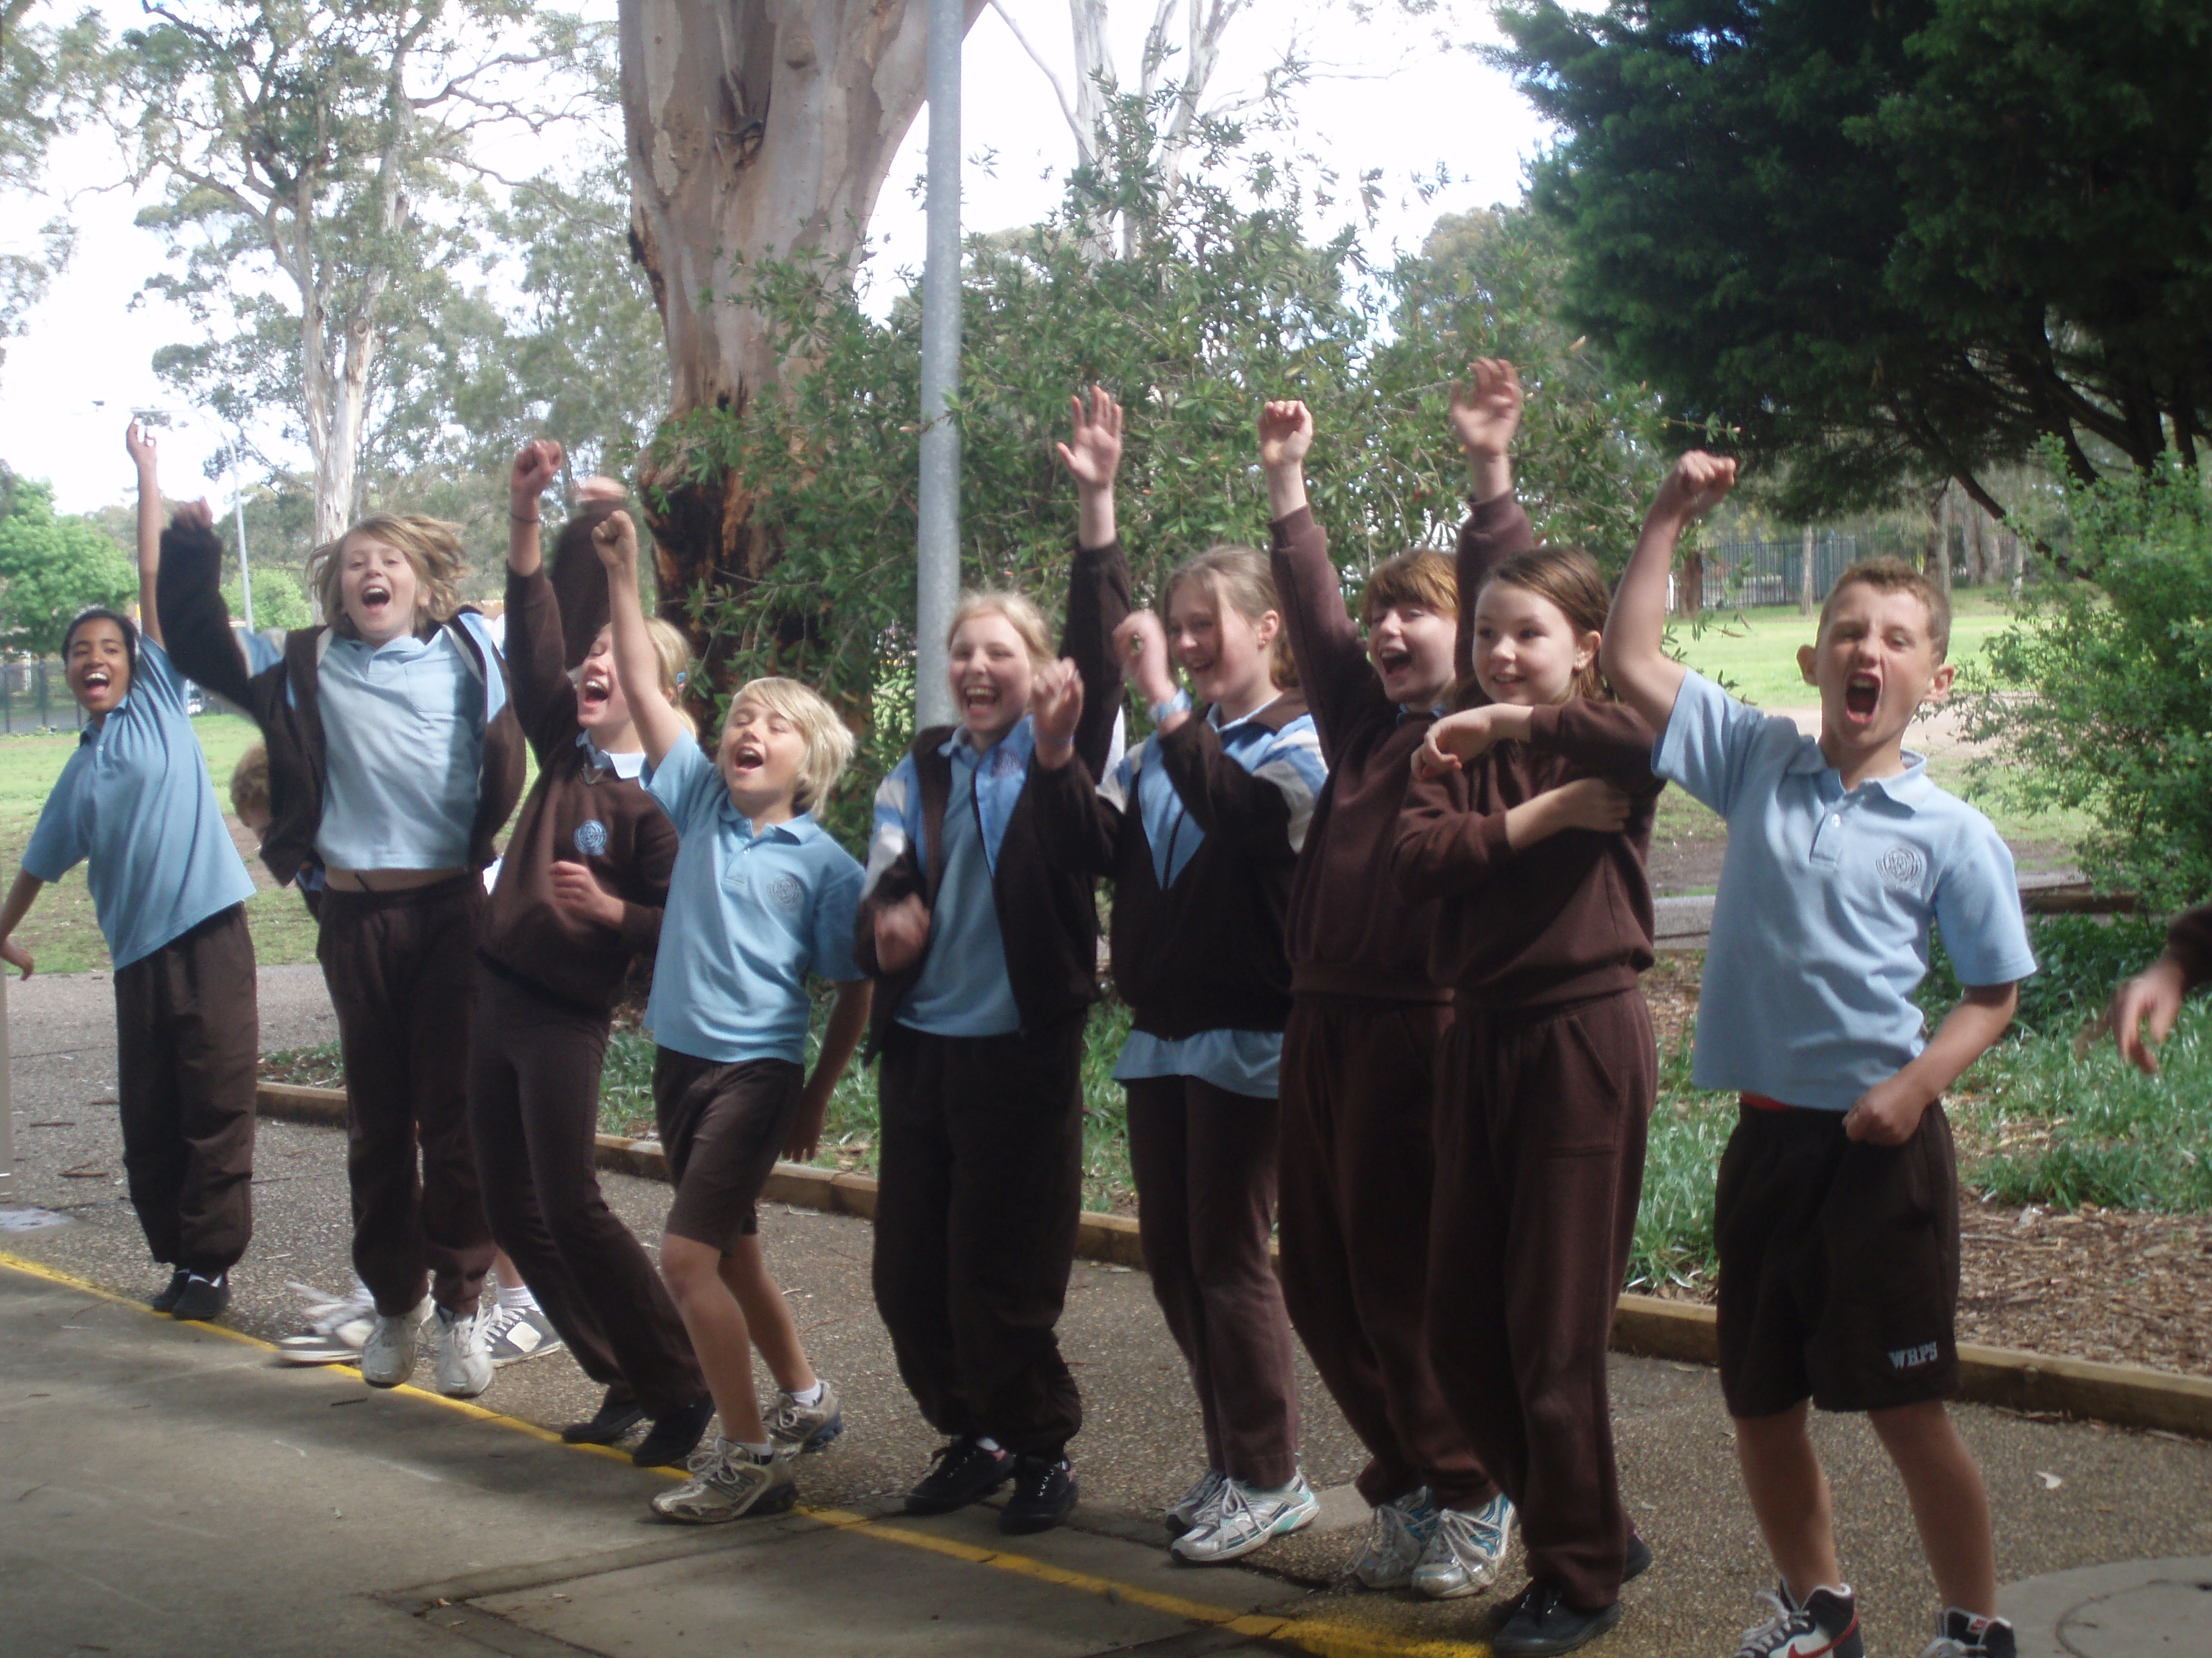

Statement of Purpose

To create a school community of positive
relationships which promote a love of life-long
learning and fosters each individual’s full potential as contributing members of Australian society.

School Rules

Be Safe
Be Respectful
Be a Learner

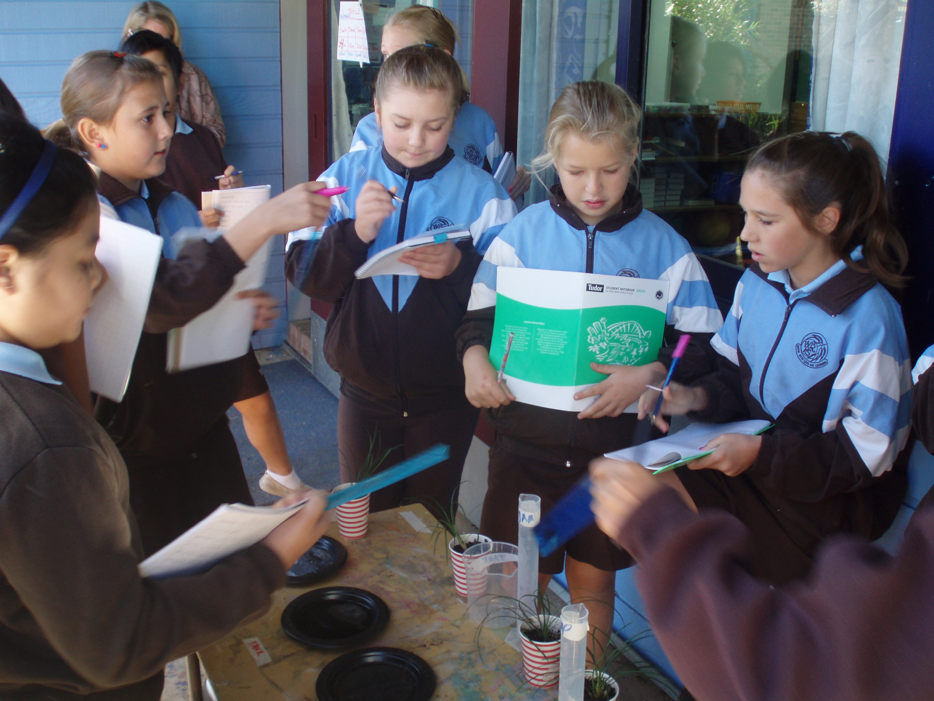

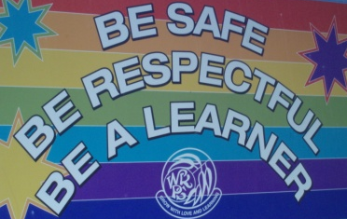

Overview

Student Welfare consists of the following components:
- Administration of medicine
- Anti-bullying programs
- Anti-racism
- Assemblies
- Behaviour Management Team
- Child Protection
- Crisis Management Plan
- Discipline Code
- Emergency Procedures
- Human Sexuality
- Individual Behaviour Management Plan
- Peer Support
- Personal Development
- Playground Procedures
- Restorative Practice
- Road Safety
- School Rules
- Support Structures for Behaviour
- Support Structures for Learning
- Suspension

In this booklet you will find the following information:

- The School Rules and Positive Behaviour Matrix.

- Strategies to promote good discipline and effective learning.

- Practices to recognise and reinforce student achievement.

- Strategies for dealing with unacceptable behaviour.

Discipline Code

It is expected that all students will follow the guidelines of the Student Welfare, Good Discipline and Effective Learning in NSW Public Schools, as set out in the Ministerial Statement (December 1995).

At Woodland Road Public School it is expected that all students will:

- Participate fully in the appropriate learning programs of the school

- Follow the expected standards of behaviour in the classroom, playground and at all school activities, to allow each child to reach his/ her maximum potential

- Show respect for and courtesy towards other students, teachers, community members and property

- Show respect to students with a disability, and any student who has an associate with a disability

- Comply with all school rules to ensure the safety of themselves and others in all school situations

- Peacefully resolve conflict in a constructive manner without violence, discrimination, bullying or intimidation

- Not be in possession of weapons, illegal drugs, alcohol or tobacco

- Adhere to the standard of dress determined by the school community

- Follow the homework policy

- Exhibit respectful behaviour towards animals either on an excursion or visit or in the school playground

- Exhibit responsible behaviour towards the use of mobile phones, visual and audio playing and recording devices


Woodland Road Public School

POSITIVE BEHAVIOUR MATRIX
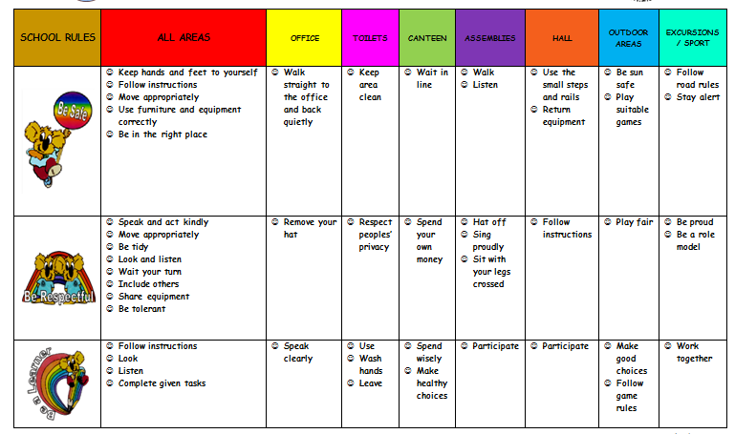

Strategies to Promote Good Learning and Effective Discipline

At Woodland Road Public School, positive discipline and effective learning is promoted by:
Providing appropriate curriculum to meet the individual needs of students
Clearly stating expectations of appropriate behaviour
The consistent implementation of school rules
The implementation of programs, policies and structures such as;
School management strategies and programs
Social skills programs
Anti-bullying programs
Learning support programs
Behaviour Management Team
Peer Support
Assemblies
School Leadership Team
Learning and Support Team
Counselling
Learning and Support Teacher
Reading Recovery
English Second Language Support
Appropriate professional development for staff
Staff and community providing role models of consistent, caring and controlled behaviour
Promoting and understanding an awareness of the roles and responsibilities of parents and caregivers in the management of student behaviour
Encouraging and expecting respect for staff, classroom helpers and each other

Practices to Recognise and Reinforce Student Achievement

The practices designed to recognise and reinforce student achievement are:

Praise and positive reinforcement

Classroom and playground management programs where students are rewarded for achieving a set goal

Awards for academic, behavioural, sporting and performance achievement

Classroom and playground tokens

Rainbow Certificates

Gold Certificate

Principal’s Award

Promoting student achievement at school assemblies and in the newsletter

Displays of students’ work

Ongoing and regular contact with parents regarding student achievements and behaviour


WRPS

Positive Acknowledgement of Student Achievement at WRPS

Students collect tokens in the classroom and playground in recognition of positive behaviour.
On the collection of 10 tokens a student will receive a rainbow certificate.
There is a set of 7 certificates to collect:
red, yellow, pink, green, purple, orange and blue.

When a student has collected a blue rainbow certificate they will receive a gold certificate from the Principal.

Gold certificate recipients will receive a badge and attend an afternoon tea with the Principal.
A token will also be collected when a student has received:

A Home Reading Certificate
A Library Award
A Year 6 Assembly Manners Award
A Blue Merit Certificate
Is in the class Max & Millie (the school mascots) visit.

Students who receive a home reading certificate will be acknowledged at a whole school assembly.
Rainbow certificates will be announced at whole school assemblies.
Stand Alone Awards:

Sport (House) Shield Awards
End of year Academic Achievement Awards
Dux of the School
Sportsmanship Awards
Service to the School Awards
Principal’s Acknowledgement of Achievement Awards
Public School Ambassador

Token collection will work as a ‘roll-over’ system allowing each student the opportunity to reach
the gold certificate level during their time at Woodland Road Public School.

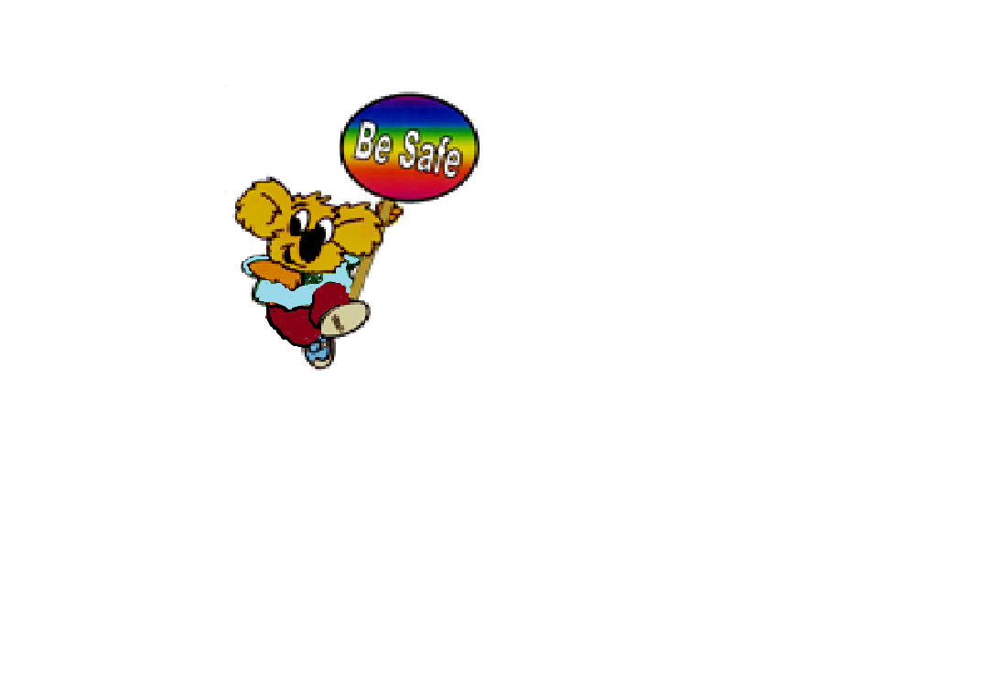
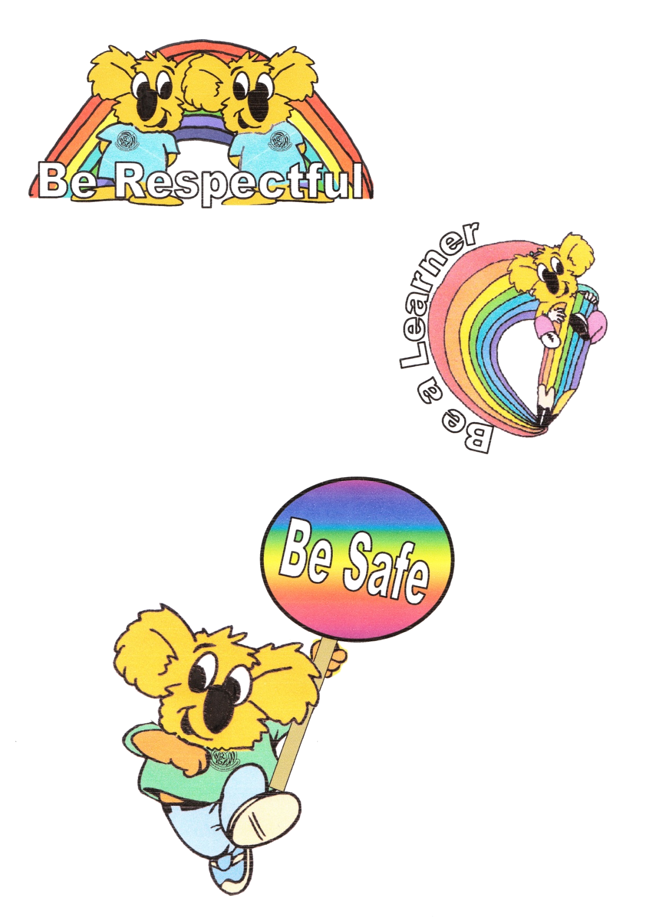
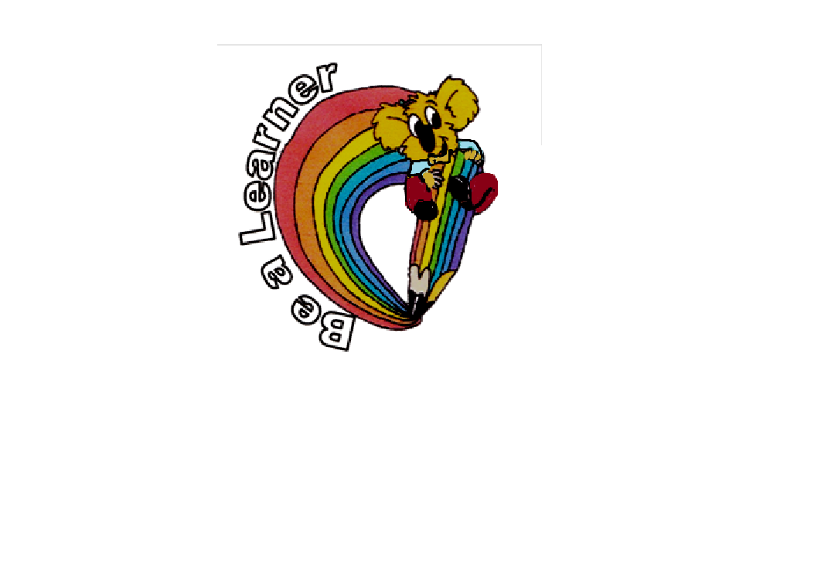

A student who has achieved the gold certificate will not receive an invitation to afternoon tea with the Principal if their positive behaviour has not been maintained.
The student will be invited to the following afternoon tea celebration if applicable.

Strategies for Dealing with
Unacceptable Behaviour

The strategies designed to manage unacceptable behaviours may include:
Teacher warnings – non verbal and verbal
Classroom and playground rules and consequences
Time out in class or on the playground
Playground Monitoring Book
Monitoring Cards
Loss of privileges
Exclusion from excursions
Exclusion from sport
Parent notification through letter, telephone or interview
Referral to Learning and Support Team and/or Behaviour Management Team
Individual Behaviour Management Plan
Self monitoring
Peer Mediation
Restorative Practices
Social skills training
Counselling
Restitution
Suspension or exclusion from school

Procedural Fairness when Dealing with Unacceptable Behaviour

Dealing with unacceptable behaviour is a shared responsibility. For it to work efficiently it is necessary for the school community (students, parents and teachers) to be aware of the processes that are in place and that communication between everyone is made frequently in a clear and concise manner. The practice of procedural fairness will be followed.

Procedural Fairness has the following elements:

The right to be heard:
To know the reason for a decision and the consequences which will flow from it
To know of the process taken to make a decision
To know about the information used to make a decision
To have the opportunity to give information which will be used in making a decision

The right of a person to an impartial decision which includes:
The right to impartiality in the investigation and decision making process
The right to an absence of bias in the making of a decision
Students experiencing difficulties with behaviour will be reviewed regularly by the Behaviour Management Team.

Little Trouble Behaviour Offences

- Being mean to others: hurtful words, not letting others play
- Teasing and name calling
- Being out of bounds
- Not keeping hands and feet to oneself
- Inappropriate rough play
- Lack of respect for property
- Avoiding telling the truth
- Deliberately littering
- Being disruptive and stopping others from learning
- Ignoring an instruction

Behaviour Management Team

The Behaviour Management Team meets weekly to monitor student behaviour through:
- Discussing student behaviour which has been registered in the playground book or reported to the Team Leaders or Principal.
- Discussing, when necessary, with the student the ownership of their behaviour and the consequences or support that he/she will be given.
Members of the team are the Principal, Assistant Principals and the Student Welfare Team Leader.

Consequences for Little Trouble Behaviour Offences
Classroom
Playground

First offence:
Student is given a warning to follow the school rules by the supervising teacher.

Second offence:
Student is reminded of the rules and the warning is reinforced.

Third offence:
Student is sent to the time out table to complete a set task.
When the task is completed the student is to move back to his/her work space.
Student’s name is to be recorded in the playground book.
The student is to be asked to walk with the teacher or sit down away from play or fulfill a community service action.
If the offence involves more than one student the supervising teacher will move through the Restorative Practice Steps.

If the behaviour pattern continues and the student reaches the third warning stage again he/she is to be sent to an assigned classroom to complete a set task.
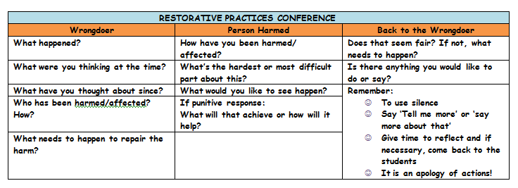

On return to the classroom the student will be expected to follow the school rules. If this is not done the Stage Team Leader will be notified and the student will be removed from the classroom. The teacher and team leader will jointly decide if the student will be placed on a monitoring card.

The student’s parents will be notified if the team leader deems it necessary.

Consequences for Middle Trouble Behaviour Offences
Middle Trouble Behaviour Offences
Classroom
Playground
Student’s name is to be recorded in the playground book.
If the offence involves more than one student the supervising teacher will move through the restorative practice steps.
A pink slip is to be filled in and handed to the Team Leader who will inform the student’s classroom teacher of the behaviour.
If the behavioural pattern is repeated the behavioural concern is to be discussed with the Team Leader, classroom teacher and the student.
If the behaviour is repeated within a two week period the student is to be placed on a monitoring card by the team leader.
If the behaviour continues during monitoring, an Individual Behaviour Management Plan will be established in consultation with the student’s parents, teacher and team leader at an organised meeting.
The student’s parents will be notified by the team leader and/or class teacher.
First offence:
Student is reminded of the school rule and is warned of the consequences.
Second offence:
Student is sent to the time out table to complete a set task.
Third offence:
If a student refuses to accept time out the team leader will be notified and the student removed from the classroom.

- Dangerously running and rushing
- Showing disrespect to people and their property
- Directed verbal abuse
- Intentionally spitting
- Being physically aggressive
- Being a member of a group which is harassing others
- Remaining out of bounds during class and playtimes
- Avoiding consequences by not relaying an accurate account of events
- Failure to follow instructions
- Showing defiance when asked to follow an instruction
- Intentionally taking something that you know doesn’t belong to you
- Continuous disruptive behaviour which stops others from learning
- Continuously refusing to work

Individual Behaviour Management Plan (IBMP)

As an inclusive school, we support students who experience difficulties self-managing their behaviour. We aim to be proactive by developing positive behaviour management plans.
The class teacher with support from the parents, team leader,
Behaviour Team and/or Learning Support Team will develop a plan to target behaviour. The IBMP will include an acknowledgement plan and a crisis plan if needed.
Strategies will include providing motivation, scaffolding and celebrating success.
Records will be kept with regular reviews to monitor the plan.


Big Trouble Behaviour Offences

- Physical aggression with intent to harm
- Bullying of any form (physical, emotional, cyber)
- For safety the student will be isolated from other students and be supported by an executive team member.
- Statements are to be collected from all involved.
- If there is a concern about student safety, refer to the school’s crisis management plan.
- Deliberate intimidation of others
- Aggressively using offensive language
- Continuously displaying a disrespectful/defiant attitude
- Wilful damage to property

The team leader will inform the student’s parents and classroom teacher of the incident and/or behaviour, whether it has been resolved or is in need of further investigation or discussion.
- Continuous noncompliant behaviour
Consequences for Big Trouble Behaviour Offences
SUSPENSION
There will be cases of unacceptable behaviour where it will be in the best interest of the school community and/or the student involved for the student to be removed from the school for a period of time or completely.
In determining whether a student’s misbehavior is serious enough to warrant suspension, the principal will consider the safety and welfare of the student, staff and other students in the class or school.
The full range of student welfare and discipline strategies will have been implemented, in most cases, before a suspension is imposed.
In some circumstances the principal may determine that a student should be suspended immediately. This will usually be due to reasons such as the safety of students or staff because of violence, the presence of weapons or illegal drugs.
(NSW Department of Education and Training: Procedures for the Suspension and Expulsion of Students).

After a discussion on the statements and information gathered between the team leader and Principal the following consequences may be imposed:
- Monitoring card
- Non participation in school events/functions
- A block of time out from the classroom and or playground
- Suspension

The Principal or team leader will contact the student’s parents to discuss the behaviour and consequences.
The class teacher and student will be notified of the consequences at this time.

The Learning Support Team/Counsellor/Behaviour Management Team are to be informed of a student who has reached this stage.

After the student has met the consequence requirement he/she will continue to be monitored by the Behaviour Management Team.

Consequences for Big Trouble Behaviour Offences
Classroom
Playground

ON TASK?
WOODLAND ROAD PUBLIC SCHOOL BEHAVIOUR MANAGEMENT PLAN

Proactive Plan
Body Language
Same eye level
Sitting beside
Approach discreetly
Gentle shoulder touch by familiar teachers
Close proximity of desk to teacher
Firm and friendly manner
System of gestures known to student by regular teachers instead of verbal warnings/praise

Verbal/Visual Encouragement
Be in the right place
Give it a go
Hand up and wait
Be safe
Use sensible talk
Keep verbal directions to a minimum
Use visual prompts and body language
Discreet and calm acknowledgement

Tangible Feedback
Class System:
Raffle tickets
Reward charts
Negotiated reward activities
Whole school rewards
Individual System:
Behaviour contracts

Crisis Plan
If a dangerous situation is in the classroom:

The students will be directed to leave and move to their support classroom
A student will go to the team leader to ask for assistance. The team leader will notify the office through a card system or phone call

If the danger is outside the room and threatening others:
The students will be directed to leave and move to a safe area
The students will be directed to sit on the floor and wait for their teacher to return after ringing the office or sending a card for assistance
The team leader will be notified of the situation

If the dangerous situation is in the playground:
The teacher on duty will notify the office.
The teacher will direct all the students to a safe area if they are being threatened. The teacher on duty will stay with all the students.
The team leader/executive will remove the student and investigate the situation

Redirection Plan
How do I bring a student back on track?
Redirection:
“Make a good choice.”
Re-verbalise appropriate behaviour
Verbalise redirection, “I want you to start.....”
Do your work and follow instructions

Direct the student through the classroom Warning Steps
as explained in the little and middle behaviour process.

Time Out
If non compliant the student is to be sent to the support class time out area
On returning to their own classroom the student is expected to comply with instruction
If the behavioural pattern is repeated the team leader is to be notified
The student will be dealt with accordingly and parents will be notified of behaviour

STUDENT BEHAVIOUR
This management plan needs to be predetermined and practiced by the whole school.
NO
SAFE
NOT SAFE
YES

